**Mechanical Design Report**

Last Updated – April, 06, 2021

Group Big Gain, ELEC 391, University of BC, Vancouver, BC, Canada

**Abstract**

Solidworks is not responding. (Talk about – drafting gripper, gears/gearbox torque reduction/speed reduction, yield/strain/stress test?, assembly of parts, motor mount, electrical component mount/harness??)



– Brief Abstract

– Nomenclature

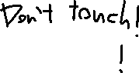

– Numbered Chapters



– References

• external sources

• appendices



**Nomenclature**

ABS Acrylonitrile-Butadlene-Styrene

**1. Design Parts & Assemblies**

**A. Components**

**B. Gripper, Arms, Joints**

**C. Inertia**

**2. Develop SX Model**

**A. Simulation Motors**

**3. Stress, Forces, and Torques**

The material properties of ABS plastic are found on the Dielectric Manufacturing Knowledge Base [1].

The Young’s Modulus of ABS is between 1.19e9 and 2.9e9 N/m^2.

The Yield Strength of ABS is between 1.85e7 and 5.1e7 N/m^2.

During the stress simulations the highest stress reached was at around 1.5e6 N/m^2 in the pincer. Given that this is 1 order of magnitude below the deformation point, only elastic deformation occurs.

**A. Pincer**

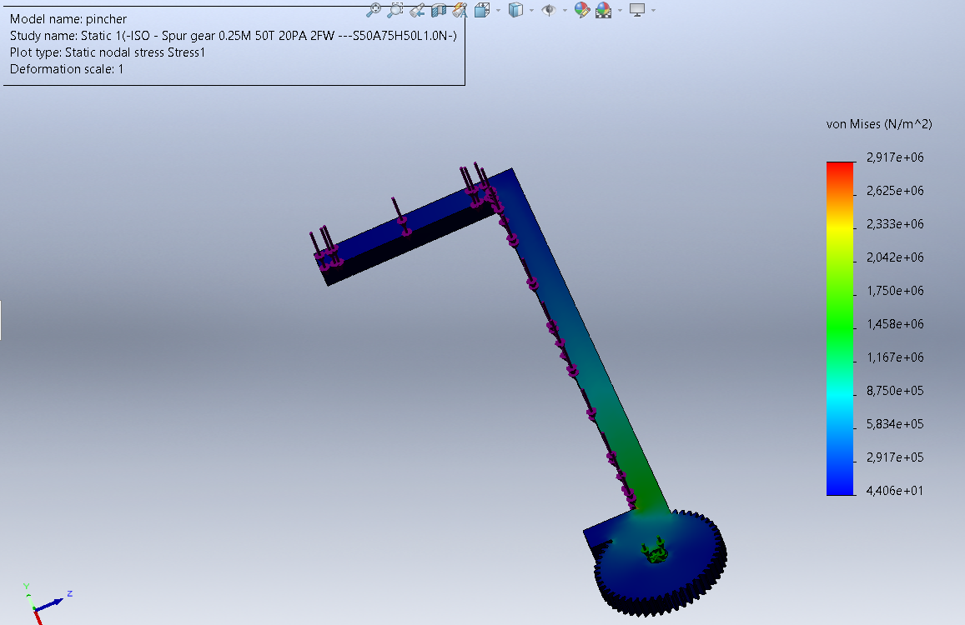

**B. Gripper Stage**

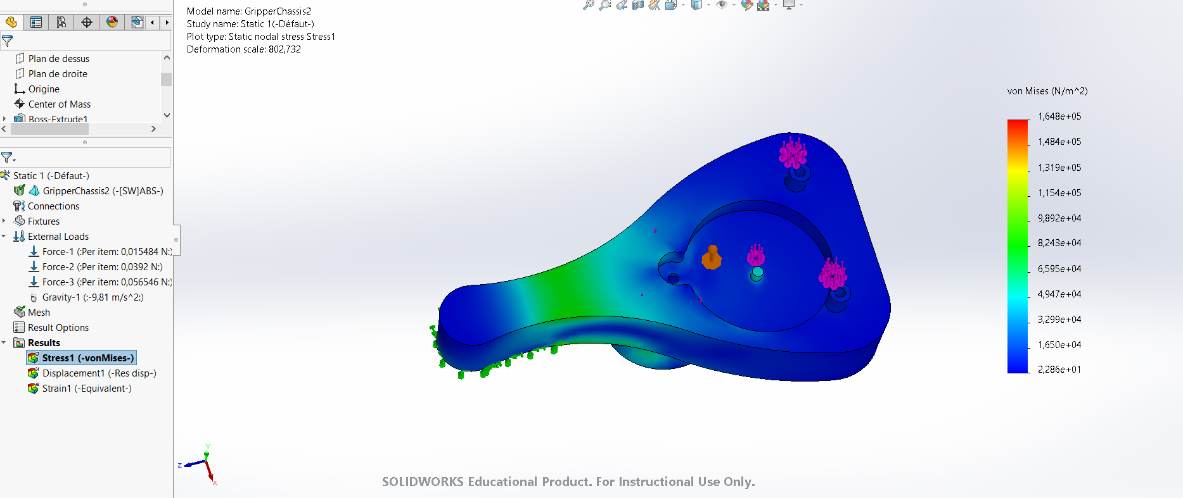

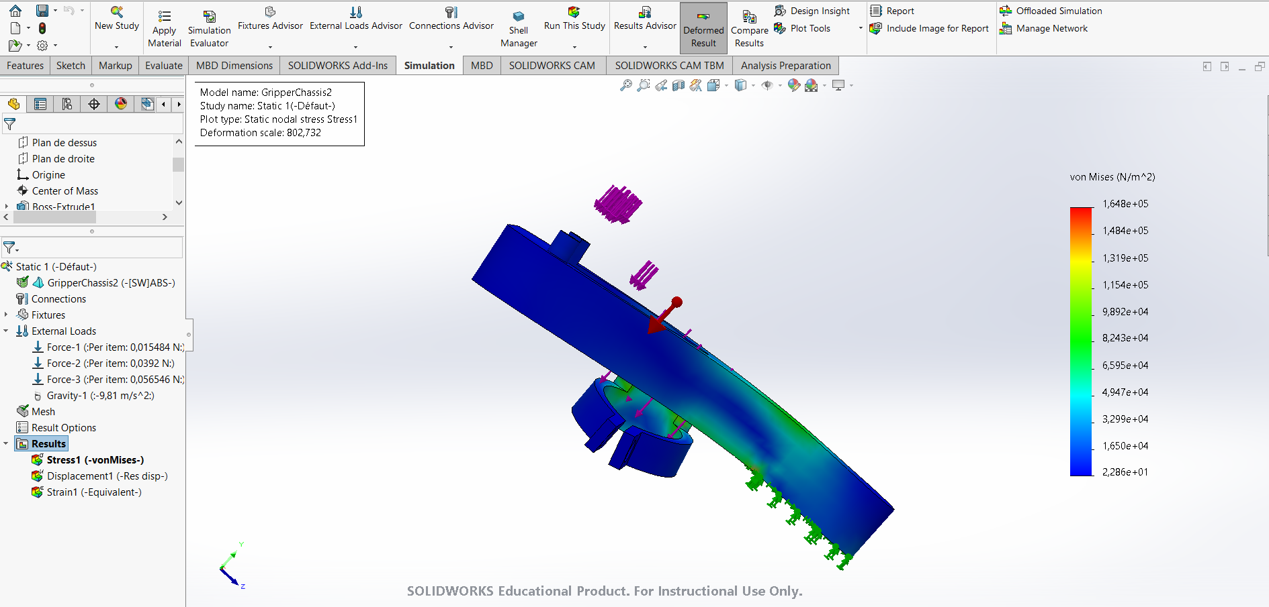

**C. Wrist & Elbow Stage**

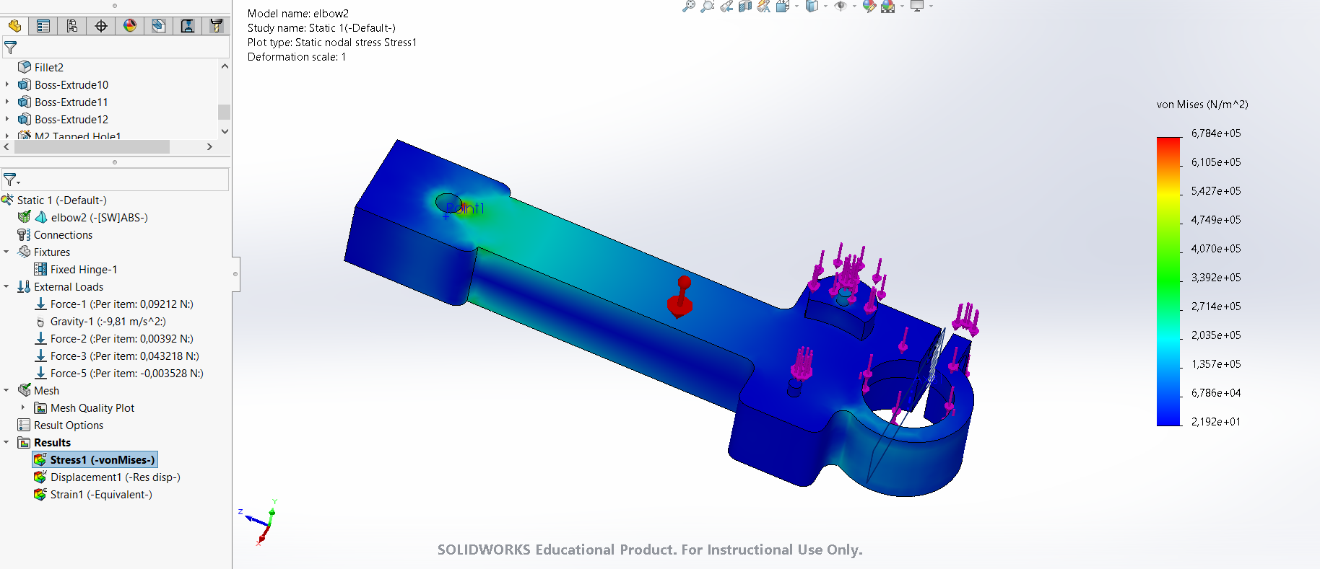

**D. Shoulder Stage**

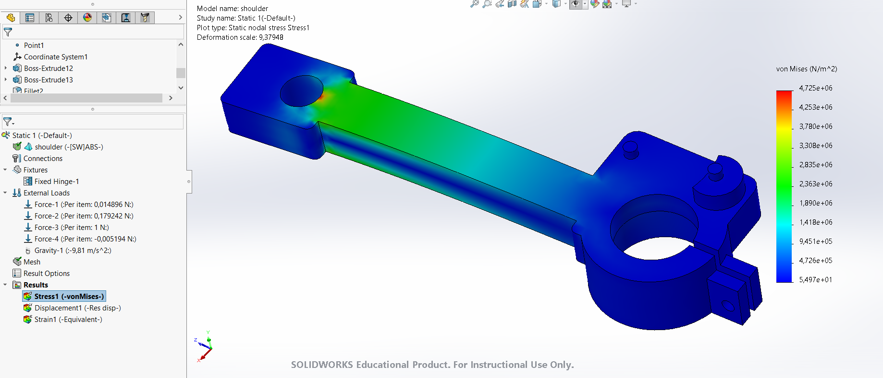

**E. Plate**

**4. Linear Approximation & Operating Point**

**A. Gripper Stage**

**B. Wrist Stage**

**C. Elbow Stage**

**D. Shoulder Stage**

**References**

**A. External Sources**

[1] Dielectric Manufacturing Knowledge Base, March 24 2020, https://dielectricmfg.com/knowledge-base/abs/